INTRODUCTION

OVERVIEW

Salesforce customer is our entire portfolio of product and service it is an integrated customer relationship management platform that helps company transform the business by uniting there marketing, sales, commerce, service and IT teams with single, shared customer view.

PURPOSE

Salesforce customer platform designed to provide comprehensive view of each customer across all touch points and system it allow business to consolidate customer data from various sources such as sales, marketing service and commerce into a single unified customer profile.

PROBLEM DIFINITION & DESIGN THINKING

EMPATHY MAP

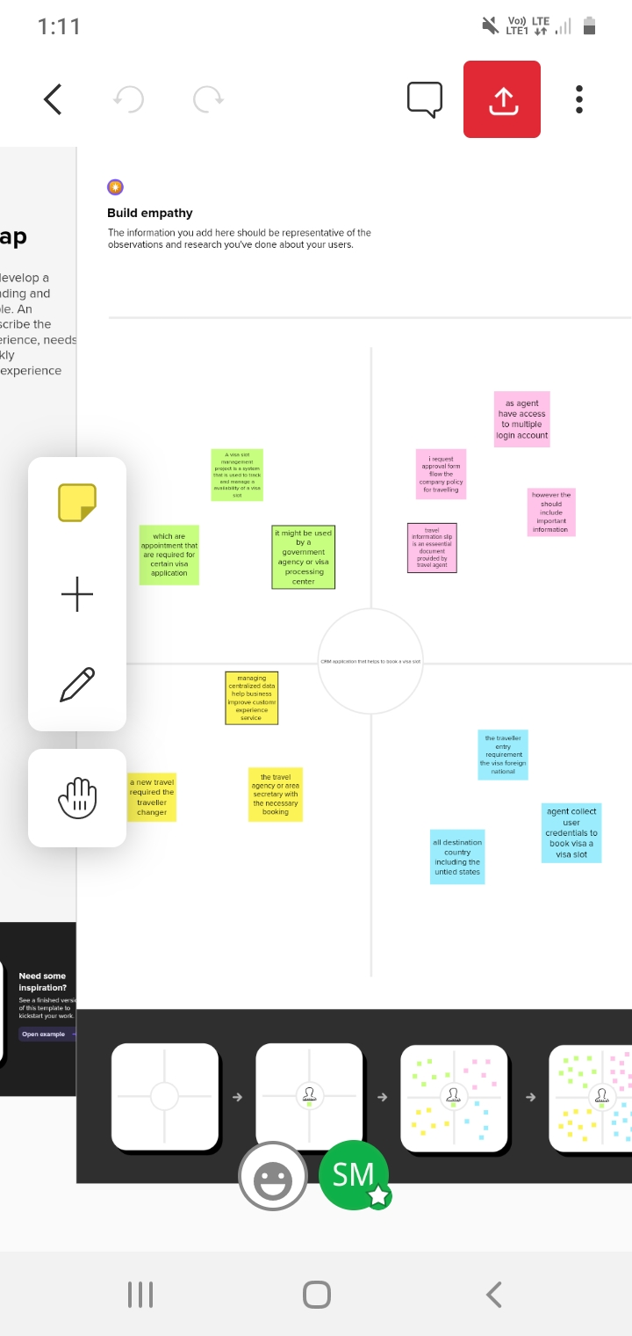

IDEATION AND BRAINSTROMING MAP

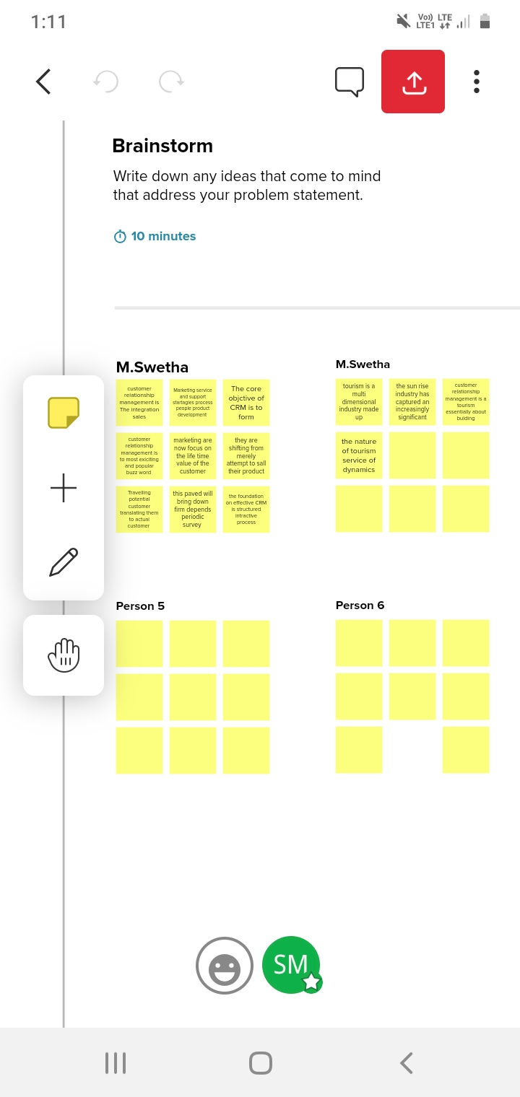

RESULT

|  |  |
| --- | --- |
| Object Name | Fields in the Object |
| Obj1 | |  |  | | --- | --- | | Fields label | Data type | | passport | text | | profile | text | |
| Obj2 | |  |  | | --- | --- | | Fields lable | Data type | | Contact number | number | | Passport number | Text | |

Activity & screenshot

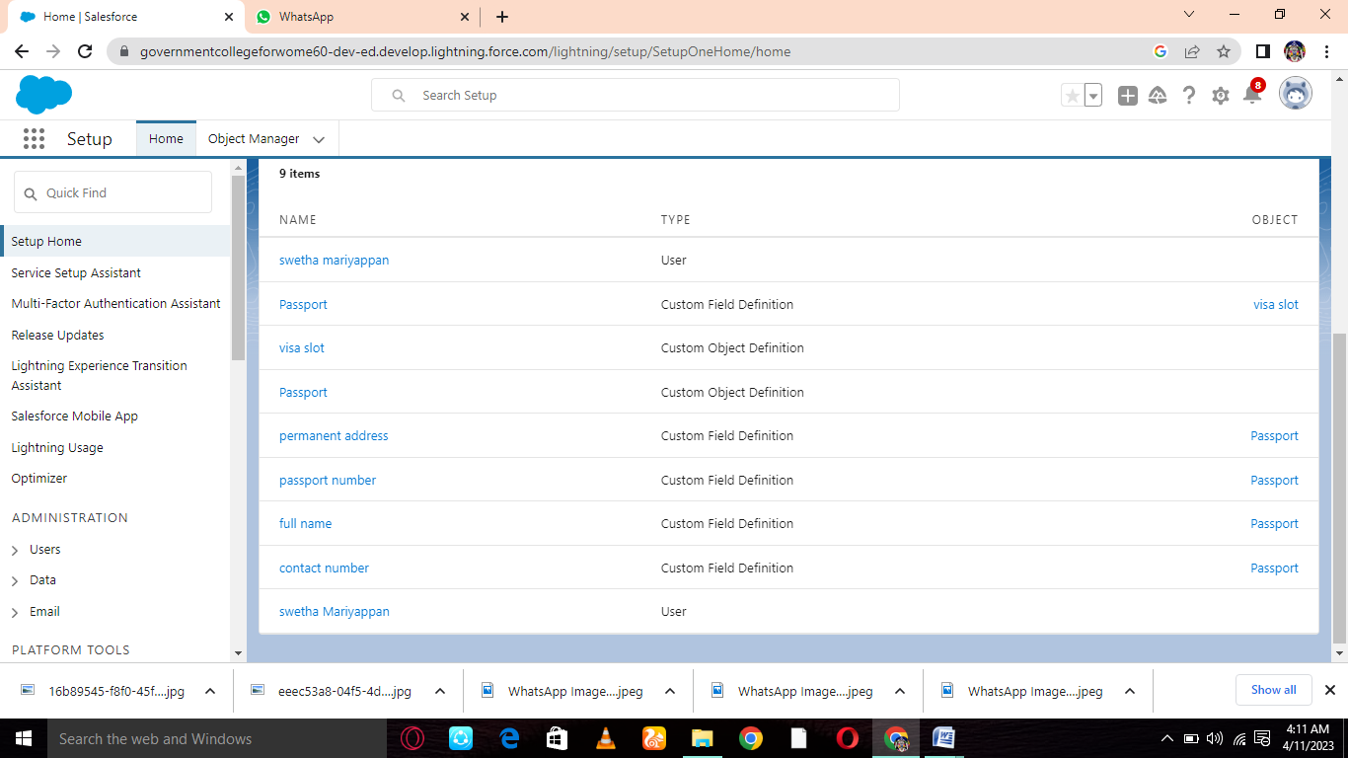

ADVANTAGES AND DISADVANTAGES

Every business is planned, established and run on based of its customer. Customer are like the blood of every business, without which business organs cannot function.

DISADVANTAGES

None

APPLICATIONS

Wheather its marketing, customer service, notification, done manually semi even fully automated with our messager communication platform.

CONCULSION

A visa slot management project is a system that is used to track and manage the availability of visa slot

FUTURE SCOPE

This will help you to track and availability of visa slot which are appointment that are required for certain visa application.